Project done by :
Obaid Salem H00531265
Zayed Jasem H00491835
Sultan Ahmed H00538220
Mansor Salem H00542927
CIS 2423 Data Analysis Project Report
Forecasting GDP and Classifying Iris Species with Python
Table of Contents
1. Purpose of the Data Analysis 2
2. Programming Language Justification 2
3. Machine Learning Algorithms Overview 2
4. Variables Selection 3
GDP Dataset Regression 3
Iris Dataset (Classification & Clustering) 3
5. Sampling Plan 4
7. Small Table of Recent GDP Values 5
8. Sampling Comparison Random vs Systematic vs Population 5
9. Visualisations of USA GDP 5
10. Hypothesis Testing (GDP Dataset) 12
11. Regression Models on USA GDP 12
12. Iris Dataset Description 13
13. Classification Models and Results 13
14. Predicting the Dependent Variable Using Best Classifier 14
15. Clustering Analysis on Iris (K-Means and Hierarchical) 14
Conclusion 16

1. Purpose of the Data Analysis
The main goal of this project is to practise the full data analysis cycle using Python:
- Choose a real dataset from a free/open source.
- Summarise the data using descriptive statistics.
- Take samples (random and systematic) and compare them.
- Build regression, classification and clustering models.
- Explain the results in simple language.
For regression, we focus on USA GDP over time and try to predict the next year’s GDP.
For classification and clustering, we use the classic Iris flower dataset, which has 3 flower species.

2. Programming Language Justification
We use Python because:
- pandas: very good for reading CSVs and cleaning data.
- NumPy: supports numerical operations.
- matplotlib: used for basic graphs scatter, box, histogram, heat map.
- SciPy: used for hypothesis tests like Pearson correlation, Spearman correlation, chi-square and t-test.
- scikit-learn: used for regression, classification, and clustering Logistic Regression, KNN, Naïve Bayes, Decision Tree, K-Means, Hierarchical clustering.
This is the same toolchain that appears in the lecture slides for classification, clustering, and hypothesis testing.

3. Machine Learning Algorithms Overview
We use the following algorithms:
- Regression GDP dataset
  - Simple Linear Regression:
    - Dependent variable (y): log(GDP Value)
    - Independent variable (x): Year
  - Multiple Linear Regression:
    - Dependent variable (y): log(GDP Value)
    - Independent variables (x): Year, lag1(GDP Value from previous year)
- Classification Iris dataset
  - Logistic Regression
  - K-Nearest Neighbours (KNN, k=5)
  - Gaussian Naïve Bayes
  - Decision Tree
- Clustering Iris dataset
  - K-Means (k from 2 to 6, evaluated by silhouette score)
  - Hierarchical clustering (Ward linkage, shown by dendrogram)

4. Variables Selection

GDP Dataset Regression
- Population (frame): All country-year GDP values from World Bank (via DataHub).
- Subset used for regression: Only rows where Country_Name = "United States".
- Dependent variable (y):
  - Value = GDP in current USD
  - For regression, we use log_value = log(Value) as the dependent variable.
- Independent variables (x):
  - Year (numeric, e.g., 1960, 1961, …, 2023)
  - lag1 (GDP Value from previous year), used only in multiple regression.

Iris Dataset (Classification & Clustering)
- Dependent variable (y) for classification:
  - class (species of iris flower: three categories)
- Independent variables (x):
  - sepal_length
  - sepal_width
  - petal_length
  - petal_width
We standardize these four numeric features when we train KNN, Logistic Regression, Naïve Bayes, Decision Tree, and K-Means.

5. Sampling Plan
We use two simple sampling techniques on the global GDP table (all countries):
- Simple Random Sampling
  - Sample size: 150 rows
  - Reason: every row has the same chance to be selected.
- Systematic Sampling
  - Sort by Year and take every 20th row.
  - Reason: easy to implement and covers the full time period evenly.
For the random sample, we also remove outliers using the IQR rule, because extreme GDP values can affect the mean.

6. Descriptive Statistics for USA GDP Dependent Variable
We used our Python function descriptive_stats() to summarise the USA GDP Value column.
Table 1: Descriptive statistics for USA GDP(dependent variable
Statistic | Value (approx.)
Count | 64 years
Mean | 8.54 trillion USD
Median | 6.34 trillion USD
Std. dev. | 7.43 trillion USD
Min | 0.54 trillion USD
75% (Q3) | 14.48 trillion USD
Max | 27.36 trillion USD
Skewness | 0.76 (right skew)
Kurtosis | -0.47 (slightly flat)
Description:
This table shows that USA GDP is right-skewed: the maximum value (27.36T) is much larger than the median. GDP has grown a lot over time, and most early values are small compared to recent years.

7. Small Table of Recent GDP Values
From the tail of the dataset, we take the last five years.
Table 2: USA GDP (last 5 years in dataset)
Year | GDP (USD, trillions approx.)
2019 | 21.52
2020 | 21.32
2021 | 23.59
2022 | 25.74
2023 | 27.36
Description:
This table shows recent GDP trends for the USA. There is a small dip in 2020 (probably due to COVID-19), and then GDP increases again in 2021, 2022 and 2023.

8. Sampling Comparison Random vs Systematic vs Population
Table 3: Comparison of means (GDP Value) for different samples
Statistic | Mean GDP (USD)
Random sample (before IQR) | 1.65 × 10¹²
Random sample (after IQR) | 5.23 × 10¹⁰
Systematic sample | 1.19 × 10¹²
Population mean | 1.21 × 10¹²
Description:
The systematic sample mean is very close to the population mean, so it represents the full data quite well.
After removing outliers from the random sample, the mean drops a lot, because we also removed many of the very high GDP values. This shows how sensitive the mean is to outliers.

9. Visualisations of USA GDP
We created four basic graphs using matplotlib:
- Scatter plot – Year vs GDP (USA)
  - Shows the relationship between Year (independent) and GDP Value (dependent).
  - The points follow an upward trend: GDP increases over time.
- Box plot – GDP (USA)
  - Shows minimum, Q1, median, Q3, maximum, and possible outliers.
  - Confirms right skew: long upper whisker and some high outliers.
- Histogram – GDP (USA)
  - Uses 20 bins.
  - Most observations are at lower GDP values; only a few years have very high GDP.
- Heat map – Correlation between Year and Value
  - The correlation between Year and GDP is very strong and positive.
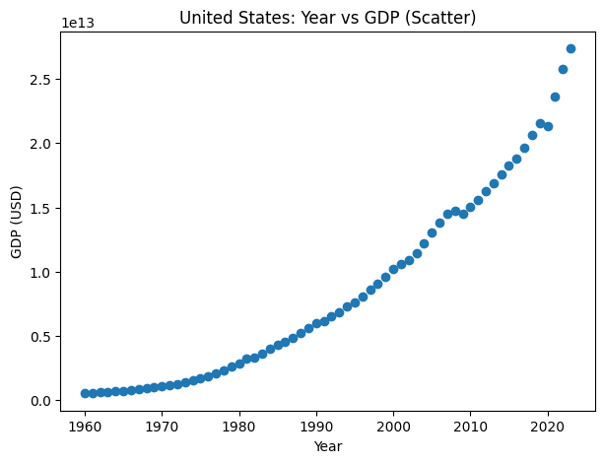
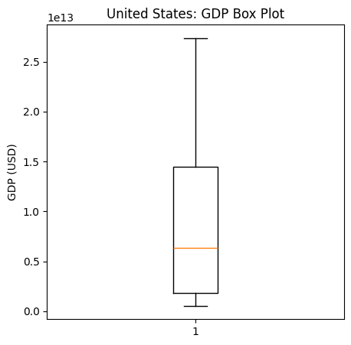
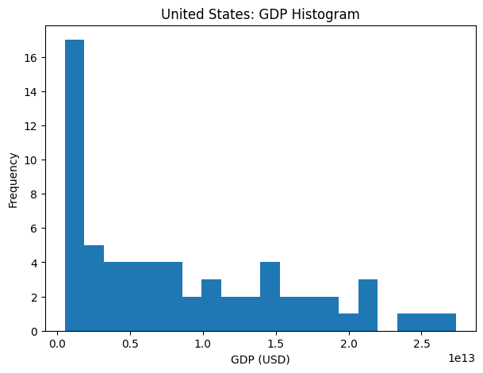
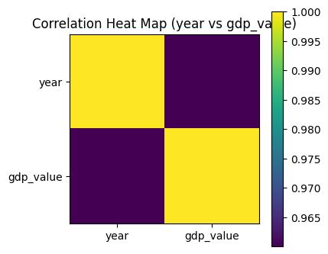
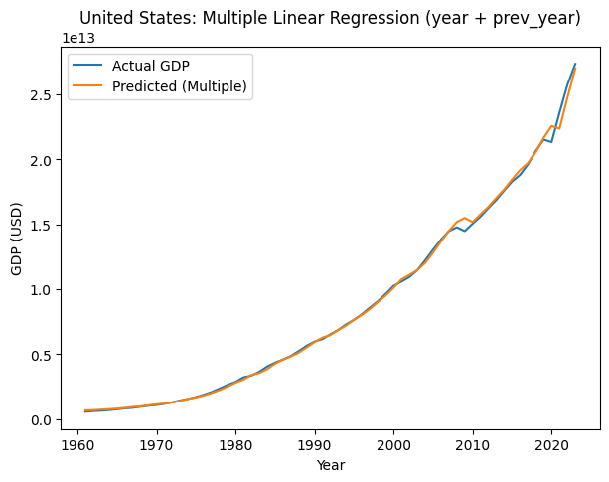
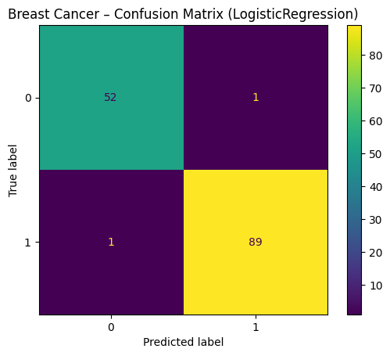
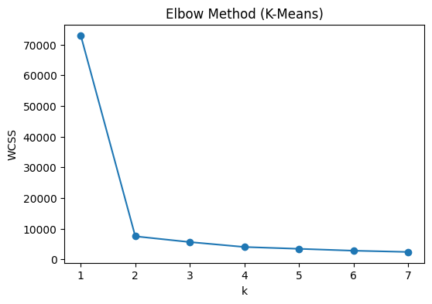
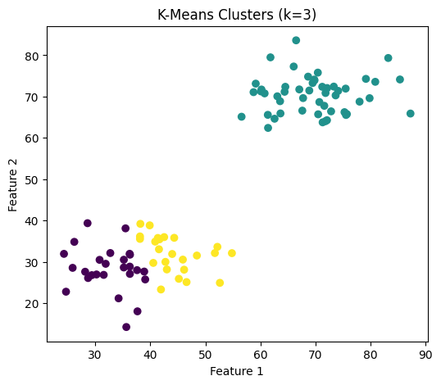
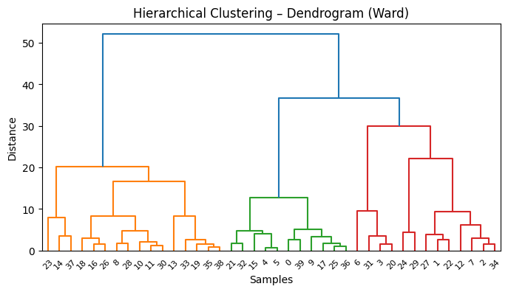

10. Hypothesis Testing (GDP Dataset)
We tested several hypotheses to check the relationship between variables.
Table 4: Hypothesis test summary for GDP dataset
Test | Value (approx.) | p-value (approx.) | Interpretation
Pearson r (Year vs Value) | 0.96 | ≪ 0.05 | Strong positive linear correlation
Spearman ρ (Year vs Value) | ≈ 1.00 | ≪ 0.05 | Very strong monotonic relationship
Chi-square (Decade vs High/Low) | 664.49 (χ²) | ≪ 0.05 | High/Low GDP depends on decade
One-sample t-test (sample vs pop) | t ≈ -137.69 | ≪ 0.05 | Clean sample mean is different from pop
Description:
- Pearson and Spearman: Year and GDP Value have a very strong positive relationship. As time goes forward, GDP almost always increases.
- Chi-square: The proportion of high vs low GDP changes by decade, so decade and HighGDP are not independent.
- t-test: The mean of the cleaned random sample is significantly different from the population mean. This is expected because we removed many high GDP values.

